Respecting Rights
My Voice My Choice!
Phase 1: What our evaluation says

ARCH Disability Law Centre
September 25, 2020

Slide 1 – Title Page
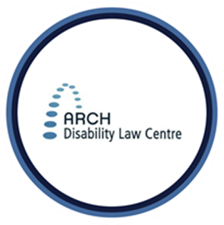
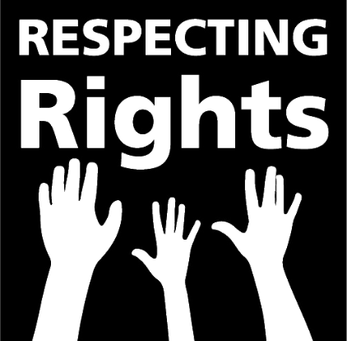

Respecting Rights
My Voice My Choice!
Phase 1: What our evaluation says
ARCH Disability Law Centre
September 25, 2020

Slide 2 - Today’s Discussion
- Stop Light Cards!
- About ARCH
- What is Respecting Rights?
- The Teams!
- Research Questions
- Results of our Evaluation Report
- What is next for Respecting Rights?
- Questions

Slide 3 - 1. Stop Light Cards!
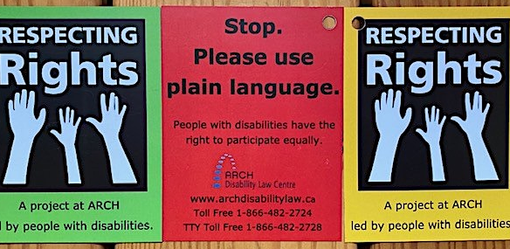

Slide 4 - STOP LIGHT CARDS WITH HOME ITEMS!

Slide 5 - 2. About ARCH
ARCH Disability Law Centre is a specialty legal clinic that practices exclusively in disability rights law
Since incorporation in 1979, ARCH has been a leader in disability rights advocacy and test case litigation.
ARCH is dedicated to defending and advancing the equality rights, entitlements, fundamental freedoms and inclusion of persons with disabilities with low income in Ontario
ARCH is primarily funded by Legal Aid Ontario

Slide 6 - ARCH Services
- Test Case Litigation
- Public Legal Education
- ARCH Alert
- Publications
- Summary Advice and Referral Service
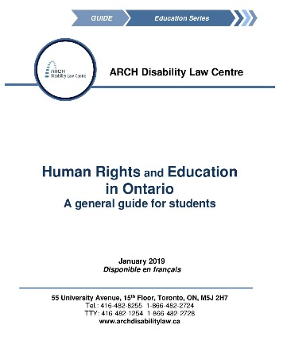
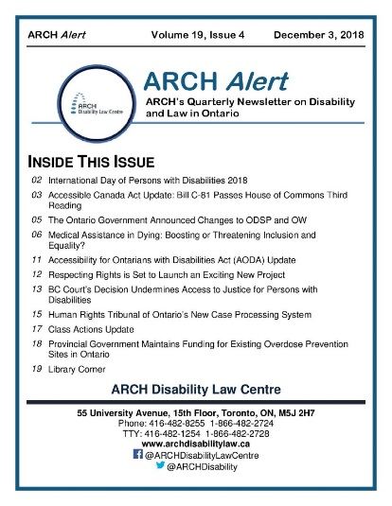
Slide 7 - 3. What is Respecting Rights?
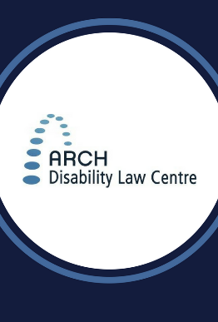
My Voice, My Choice: Evaluating Decision Making Rights Education In Central, Eastern and Western Ontario
- Respecting Rights is a rights education project at ARCH Disability Law Centre, led by people with disabilities
- We work in a TRIPLE SCOOP way – with lawyers, self-advocates, and social workers working together
- We wanted to learn about how people with intellectual disabilities are supported to make their own decisions
Slide 8 - Thank you to the Ontario Government for funding our project
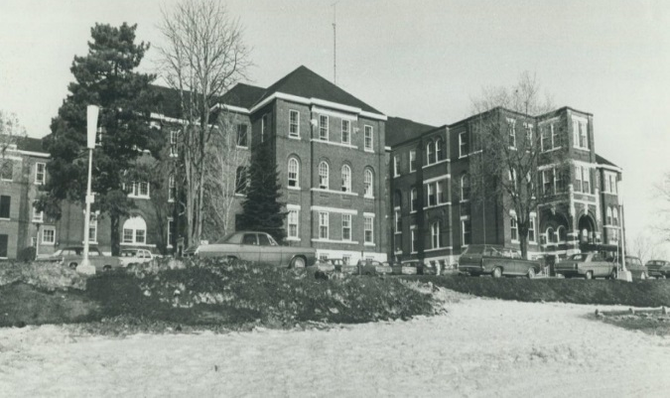

- After the Huronia Class Action Law Suit, leftover funding was available for new projects
- Respecting Rights is grateful to receive this funding
- We committed to using it to help improve lives of people with disabilities. We wanted to help people with disabilities learn about their right to make decisions

Slide 9 - 4. The Teams!
Thank you to our team of core self advocates who worked hard on My Voice, My Choice Phase I
- Self advocates made role plays from stories about their lives. Together, we turned these into scripts.
- Self advocates acted in videos to help others learn about their rights
- Self advocates learned and practiced skills of “peer” support – of listening to other self-advocates talk about their rights
- We did workshops that self-advocates lead with support of lawyers and social workers in 3 areas of Ontario: Western (London), Central (Toronto), and Eastern (Ottawa)
- At these workshops, self advocates helped lead role plays with other self-advocates. We also created art and shared stories.
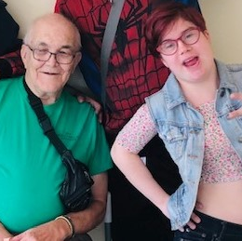

Slide 10 - Our Self Advocate Leaders
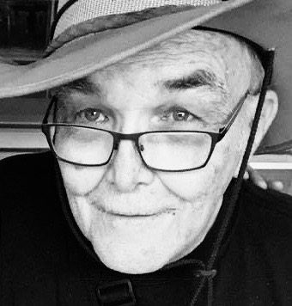
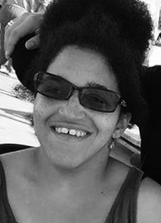

Slide 11 - Western Ontario – London
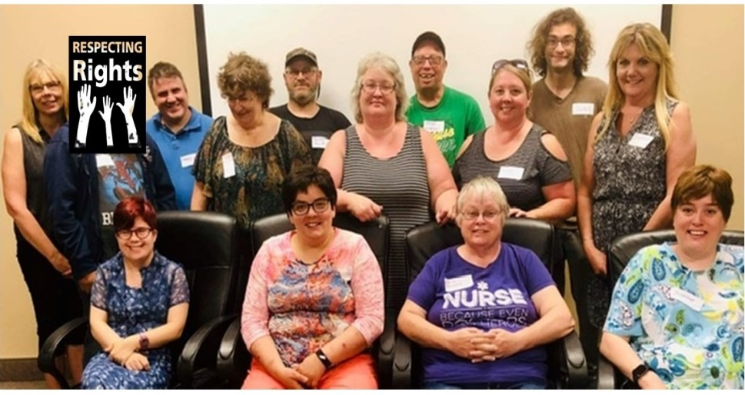

Slide 12 - Eastern Ontario – Ottawa
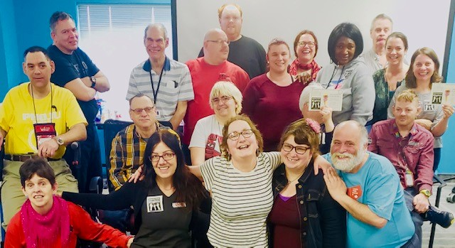

Slide 13 - Central Ontario – Toronto
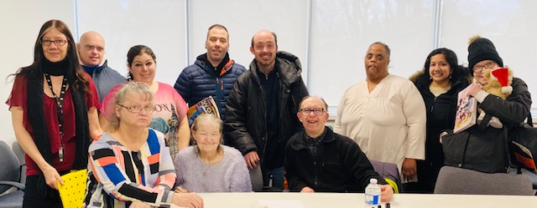

Slide 14 - Thank you My Voice My Choice Regional Support Staff
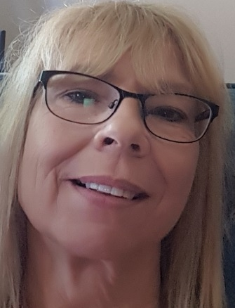

Vicky Pearson, London, Ontario; Josée Boulanger, Ottawa, Ontario and Tara Bates, Toronto, Ontario
Slide 15 - Our Topics!
Self advocates decided on topics that were most important to talk about:
- Relationship Decision-making rights
- Money Decision-making rights
- Health care Decision-making rights
- Daily living Decision-making rights

Slide 16 - Laws that Apply
- Human rights laws continue to apply
  - International Agreements (e.g. UN CRPD)
  - Human Rights Code
- Key legislation in the developmental services sector:
  - Services and Supports to Promote the Social Inclusion of Persons with Developmental Disabilities Act, 2008 [“Social Inclusion Act”]
- Several Acts deal with aspects of decision-making and mental capacity:
  - Substitute Decisions Act, 1992
  - Health Care Consent Act, 1996
  - Mental Health Act, 1990

Slide 17 - 5. Research Questions
I. Is it possible to create supported decision-making circles for people labelled with an intellectual disability?
II. Have people learned any new information or skills from the Respecting Rights workshops?
III. Do the Respecting Rights workshops about supported decision-making help people?
IV. Do the Respecting Rights workshops help people to be more involved in decisions about their life?

Slide 18 - We asked Eviance to evaluate our project
- We wanted experts in “evaluation” to find out how helpful My Voice, My Choice is for people
  - Cam Crawford used to live in a L’Arche community and has lots of experience in disability evaluation
- Self Advocates filled out forms and answered questions after every workshop
- Evaluator met with a group of self-advocates over Zoom to find out more
- We hoped to have a gathering of all our self-advocates at the end, but Covid-19 prevented that

Slide 19 - 6. Results of Our Evaluation Report!
I. Is it possible to create supported decision-making circles for people labelled with an intellectual disability?
The findings support the conclusion that people found MVMC a rewarding process and would welcome opportunities to continue coming together in this way in the future
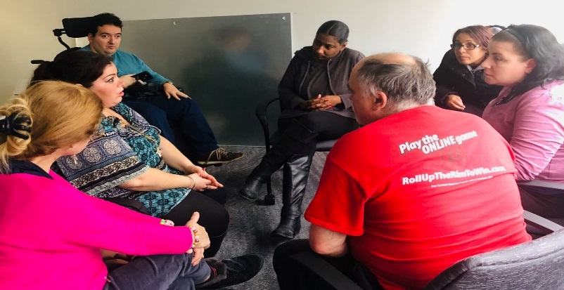

Slide 20
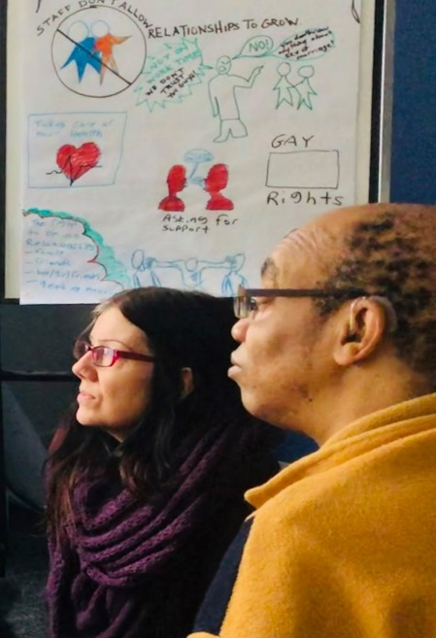
We listened to each other’s stories about rights and decision making
Self advocates can draw pictures of what is important to them

Slide 21
Self advocates said they really like listening to each other and talking to lawyers about their rights
“We have the right to speak about how we feel. And no judgement.”

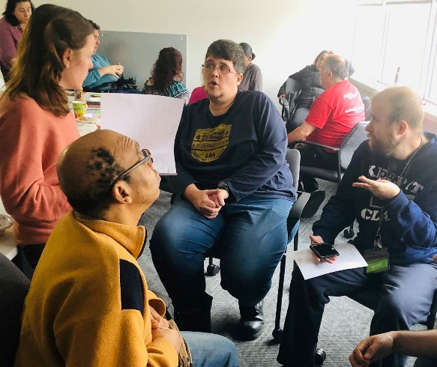

Slide 22 - 6. Results of Our Evaluation Report!
II. Have people learned any new information or skills from the Respecting Rights workshops?
83% learned new things about their
rights at MVMC sessions

Slide 23 - 6. Results of Our Evaluation Report!
III. Do the Respecting Rights workshops about supported decision-making help people?
- 57% said they felt “a lot more confident” to advocate after attending the MVMC sessions
- 29% said they were “a little more confident” to advocate after attending the sessions
- 14% said their confidence level was about the same as it was before
- No one said they felt less confident after attending the MCMV sessions.
*Based on the answers of people who attended the last session in Ottawa

Slide 24 - 6. Results of Our Evaluation Report!
IV. Do the Respecting Rights workshops help people to be more involved in decisions about their life?
- Many self-advocates who participated shared that they have thought about advocating in the future
- Nearly half of the people said they would ask questions or speak up for themselves as one way to advocate for themselves (45%)
  - “Say what's on my mind more often.”
  - “Maybe talk to my residential staff about having control of my money.”
  - “I would talk about my feelings to advocate for myself"

Slide 25 - FOOD GLORIOUS FOOD!
Many participants told us they loved the food at our sessions! It’s welcoming.
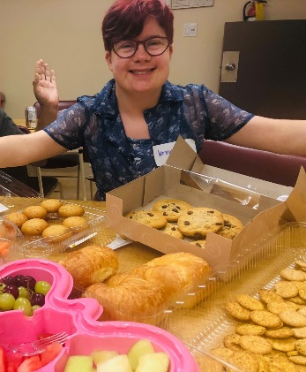
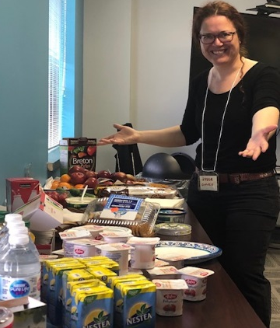
Thank you to wonderful staff such as Joseé, Vicky, Tara for arranging for the snacks!

Slide 26 - Role Play
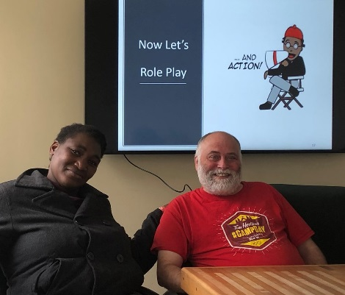
- Respecting Rights has been using role play and art in rights education for many years.
- We decided to study how our work helps people with intellectual disabilities learn about decision making rights

Slide 27 - Laughing in a role play in London
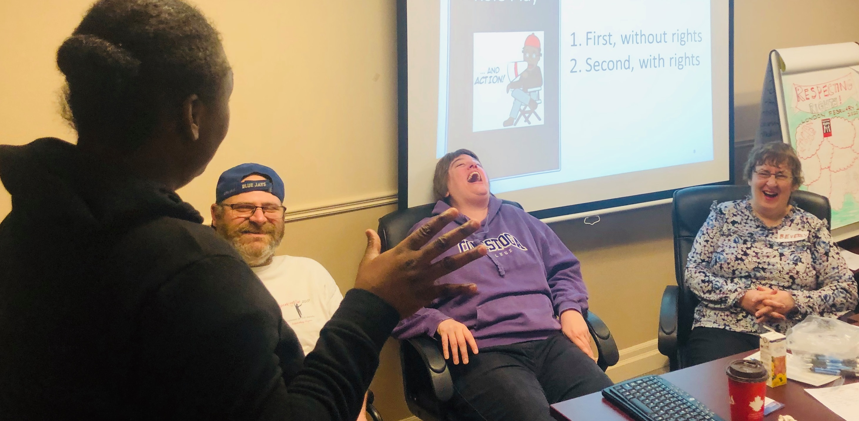
Slide 28 - Relationship Decisions
EVERYONE said they learned something new in our sessions on Relationship Decisions (100%).
“Relationships are important and we need to be heard.”
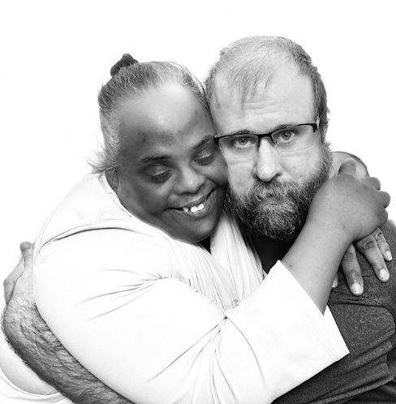

Slide 29 - Robert’s Video about Relationships
https://www.youtube.com/watch?v=5i-KndWJHWs

Slide 30
The quotes are anonymous
No names are in the report

Slide 31 - More things people said they learned
“I need to speak up to my family to let them know what's important to me.”
“That we’re allowed to complain about financial problems.”
“I learned that you can advocate and stand up for yourself and support about your wishes, goals, decision making.”
“People have rights.”
“I'm important. What I think matters.”

Slide 32
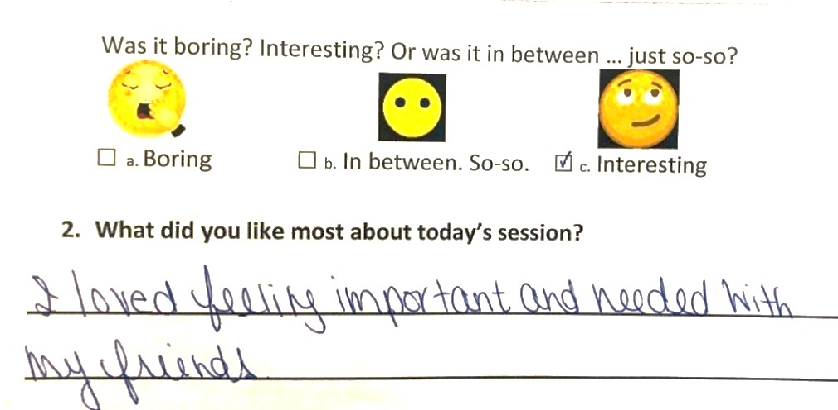

Slide 33 - Art by self advocates is in the report
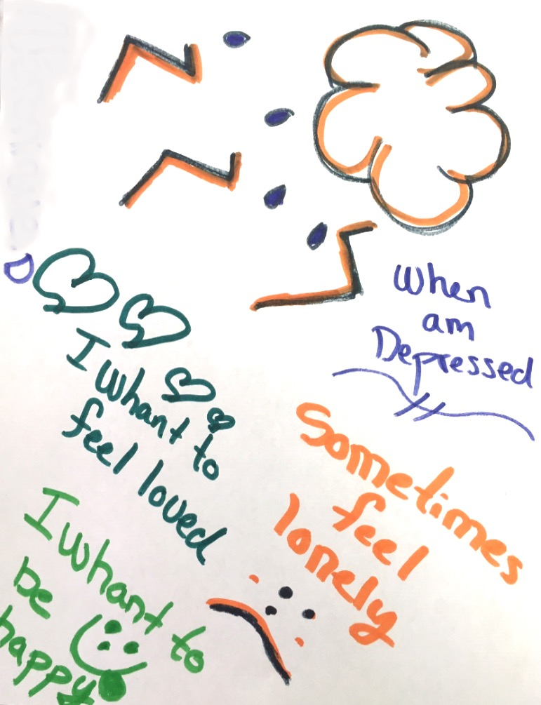

Slide 34
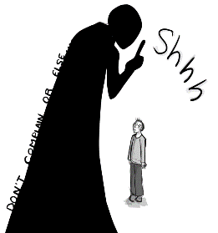
"It's not worth complaining. We know we will get in trouble if we speak up. Staff tell us to be quiet and it's worse when you speak out."

Slide 35 -
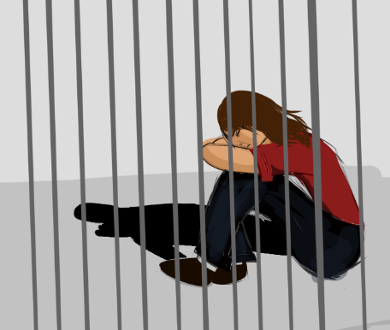
"We feel like we are in jail. We are not allowed to make our own decisions about our own lives."

Slide 36
“We get to choose who we have relationships with”

Slide 37
“If all the people with disabilities made complaints, it would be a volcano exploding. That’s because so many people have complaints they don’t make”

Slide 38
“We needed more time for small group talks”
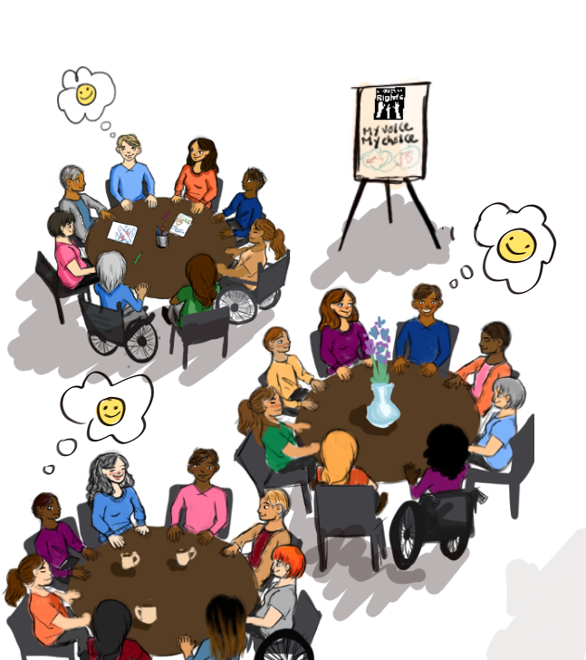

Slide 39 - 7. What is Next for Respecting Rights?
- Advisory Regional Groups?
- Regional Representatives?
- Respecting Rights work with agencies
  - Create bills of rights with self-advocates
  - Complaint mechanisms

Slide 40 - Goals of Working with Agencies
- Addressing some of the limitations of the Social Inclusion Act
- Removing barriers that that will enable people with intellectual disabilities to exercise more independence, have greater decision-making power over their day-to-day lives, and ultimately live as full citizens in communities of their choosing.
- Exploring the minimum standards that service providers, community agencies that administer funding or process applications must comply to ensure quality assurance

Slide 41 - Thank you!
YouTube channel: www.bit.ly/2InNAiJ
@respectingrights
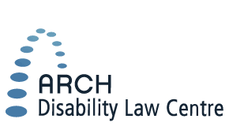
@ARCHDisability
@ARCHDisabilityLawCentre
55 University Avenue, 15th Floor
Toronto, ON, M5J 2H7
Tel: 416-482-8255 or 1-866-482-2724
TTY: 416-482-1254 or 1-866-482-2728
Fax: 416-482-2981 or 1-866-881-2723
www.archdisabilitylaw.ca

Slide 42 - 8. Questions?

